**Assignment 1**

ME 423 - Machine Design



**Department of Mechanical Engineering**

**Indian Institute of Technology, Bombay**

Date: 09/08/2024

**Submitted by: Hanish Dhanwalkar**

**Roll no: 210100060**

**STAPLER:**

A stapler is used to bind sheets together by driving a staple pin through the sheets and folding the ends of the staple to hold the sheets in place.

**Functioning of the Stapler**:

1. Place the sheets to be stapled between the base and the head of the stapler.
2. Top handle of the stapler is pressed down, it forces a staple into the paper.
3. The staple passes through the sheets and hits the anvil, a small metal plate on the base, which bends the legs of the staple into the sheet.

**Safety Features:**

Safety features to prevent accidental injury:

1. locking mechanism that prevents the stapler from being pressed downwards unless a certain amount of pressure is applied, reducing the risk of accidental stapling.
2. A safety shield over the staple exit point to prevent fingers from being accidentally stapled.

**Different Parts of the Staplerr and Assembly**

A stapler consists of several key parts:

1. Base: The bottom part that rests on the table. It provides stability and houses the anvil.
2. Anvil: A small metal plate on the base that bends the staple legs to secure the paper.
3. Head: The top part that is pressed down to drive the staple. It contains the magazine and the driver blade.
4. Magazine: Located inside the head, it holds the staples in place and feeds them into the stapling mechanism.
5. Driver Blade: A metal piece that pushes the staple out of the magazine and into the paper.
6. Spring: Located in the magazine, it keeps the staples loaded and ready to be driven out.
7. Handle: The upper part of the stapler that is pressed down to activate the stapling mechanism.

The magazine is inserted into the head, followed by the spring and the driver blade. The head is then attached to the base with a hinge that allows it to move up and down about the joint. The handle is fixed on top of the head.

**Materials Used for Different Parts:**

* Base: Usually made of metal or plastic providing durability and weight for stability, while plastic can be used for lighter, more portable staplers.
* Anvil, Driver Blade: Made of metal like hardened steel that can withstand the repeated force of the staple being bent..
* Head: Made of metal or high-quality plastic for durability.
* Spring: Made of steel for its elasticity.
* Magazine: Made of metal to withstand the constant pressure from the spring and the force exerted by the driver blade
* Handle: Can be made from metal, plastic, or a combination of both.

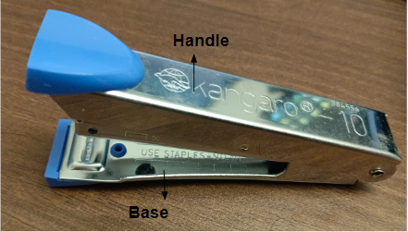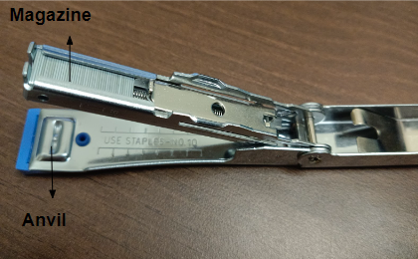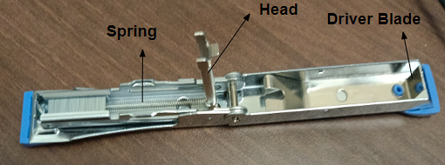

**Fig**. Labels of the major parts of a stapler